July 24, 2021

Brian Collins

Student ID: 2078876

Word Count (excl. tables): 1631

Data Analytics & Management

Assignment 1: Analysis of a Motor Insurance Company

**Introduction**

The purpose of this report is to conduct exploratory data analysis of a dataset of observations describing insurance coverage, claims and claim payouts. This report will describe the data contained therein and provide descriptive statistics of the underlying variables before conducting a correlation analysis. Finally, this report will produce a linear regression analysis to create models that can be applied in estimating claim numbers and values to aid in financial and resource planning.

*Dataset Overview (Assumptions found in Appendix 8)*

*Kilometres* – listing distance groups in order from smallest to largest, represented as an integer.

Figure : Bar chart showing the average number of claims by distance group

*Zone - In a broadly descending order of size, zone-clustering regions of the country are* represented as an integer.

Figure : Waffle chart of claims by Zone, one square = 250 claims

Figure : Average number of claims by geographic Zone.

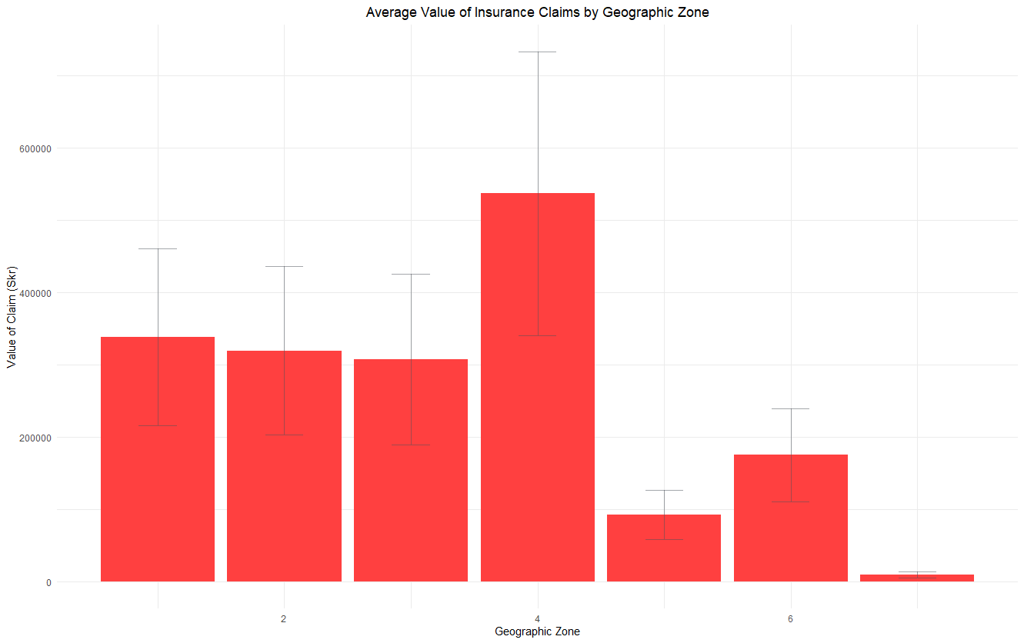

Figure : Average value of claims by geographic Zone

*Bonus* – representing the number of years no claims bonus (NCB) since the last claim, represented as an integer.

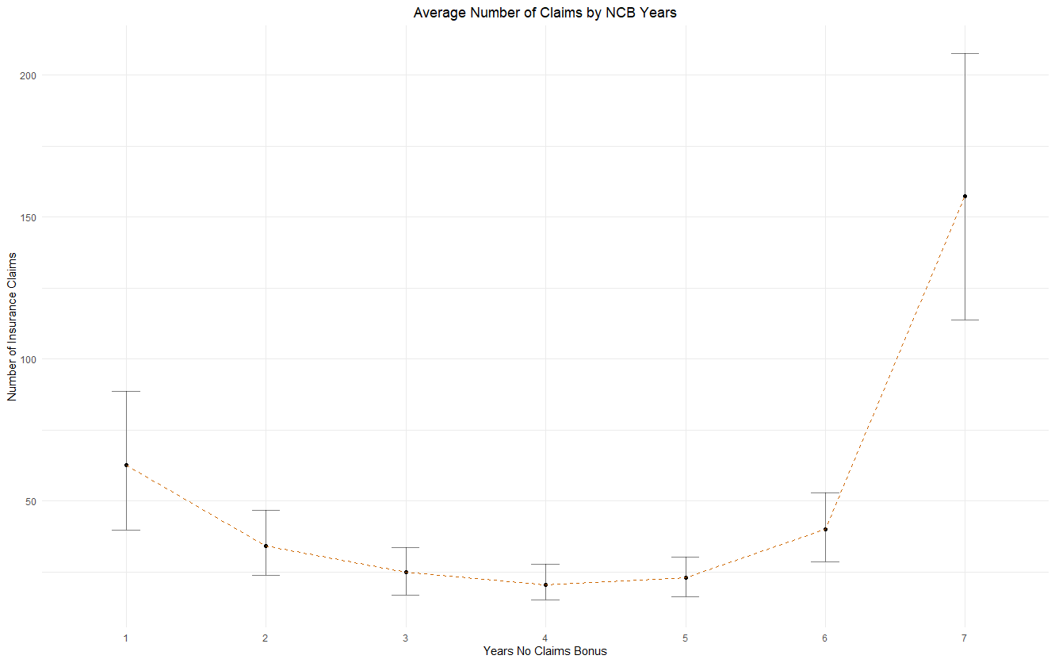

Figure : Average number of claims by years NCB

*Make* – Integers representing the eight most popular car manufacturers in Sweden. All other vehicles are clustered into group nine.

Figure (a): Boxplot showing claim number quartiles, whiskers incl. outliers

Figure 6(b): Boxplot showing claim number quartiles, whiskers excl. outliers

*Insured –* Numerical data representing the number of the insured policy years.

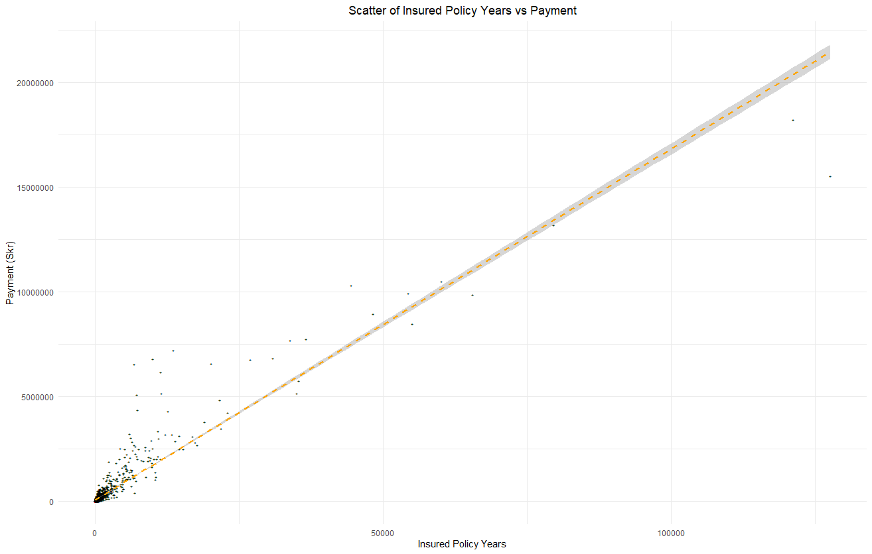

Figure : Scatter graph of insured policy years and Payment

*Claims –* Integer representing the number of claims made against insurance policies.

Figure : Scatter of policy claims vs payments

*Payment – Total value of insurance payouts made against policies in Swedish Krona (Skr), represented as an integer.*

Descriptive statistics for non-categorical variables can be found in Table 1.

|  |  |  |  |  |  |  |  |  |  |
| --- | --- | --- | --- | --- | --- | --- | --- | --- | --- |
|  | Min | Max | Range | Sum | Med | Mean | CI of Mean (95%) | Var | Std. Dev |
| Insured | 0.01 | 127,687.27 | 127,687.26 | 2,383,170.08 | 81.525 | 1,092.1953 | 237.6659 | 32,048,690.03 | 5,661.1562 |
| Claims | 0 | 3,338 | 3,338 | 113,171 | 5 | 51.8657 | 8.4682 | 40,687.2039 | 201.7107 |
| Payment | 0 | 18,245,026 | 18,245,026 | 560,790,681 | 27,403.5 | 257,007.6448 | 42,707.4271 | 1.03486E+12 | 1,017,282.586 |

Table : Descriptive statistics for insurance dataset

**Establish whether there is a preexisting relationship between insurance payments amount and other tracked variables.**

*Method*

Before undertaking any statistical correlation testing, it was first necessary to perform a visual analysis of key variables using scatter plots to determine the relationships between variables. However, these scatter plots were only helpful in comparing parametric data, and as such, Kilometers, Zone, Bonus, and Make, as ordinal data are more straightforward to infer through bar charts.

A Shapiro-Wilk was used to ascertain the probability of data having been sampled from a normally distributed population. For all variables, the test indicated that this probability was 2.2e-16. The null hypothesis, stating the data was sampled from a normally distributed population, can be rejected. With this, Pearson could be rejected as an appropriate test of correlation between the data. As a result of this, Spearman's Rho was selected given the previously established monotonic relationship, the non-normalcy of the data distribution, and variable types.

*Analysis*

Table 1 represents a matrix of Spearman's Correlation Coefficients between all variables in the dataset. Payment has a strong positive correlation with both claim number and the number of insured in policy years, with values of 0.9030 and 0.9624, respectively. Bonus and Make also both had weak positive correlations with Payment, with 0.2021 and 0.1182, respectively. Finally, Kilometres and Zone both had moderate negative correlations of -0.2418 and -0.3634, respectively.

P-Values for the correlation analysis can be found in Table 2. In all cases, calculated values were less than 0.05, and as such, the null hypothesis, stating that no relationship is present, can be rejected in all cases.

|  |  |  |  |  |  |  |  |
| --- | --- | --- | --- | --- | --- | --- | --- |
|  | Kilometres | Zone | Bonus | Make | Insured | Claims | Payment |
| Kilometres | 1 | -0.01393 | 0.007206 | -0.00268 | -0.32902 | -0.26426 | -0.24218 |
| Zone | -0.01393 | 1 | 0.011674 | -0.00519 | -0.32006 | -0.38682 | -0.36345 |
| Bonus | 0.007206 | 0.011674 | 1 | 0.002157 | 0.351141 | 0.197773 | 0.202058 |
| Make | -0.00268 | -0.00519 | 0.002157 | 1 | 0.111041 | 0.112388 | 0.118209 |
| Insured | -0.32902 | -0.32006 | 0.351141 | 0.111041 | 1 | 0.933337 | 0.903032 |
| Claims | -0.26426 | -0.38682 | 0.197773 | 0.112388 | 0.933337 | 1 | 0.962443 |
| Payment | -0.24218 | -0.36345 | 0.202058 | 0.118209 | 0.903032 | 0.962443 | 1 |

Table 2: Spearman's Rho correlation coefficients

|  |  |  |  |  |  |  |  |  |
| --- | --- | --- | --- | --- | --- | --- | --- | --- |
|  | Kilometres | Zone |  | Bonus | Make | Insured | Claims | Payment |
| Kilometres | NA | 0.515516 |  | 0.736568 | 0.900551 | 0 | 0 | 0 |
| Zone | 0.515516 | NA |  | 0.58573 | 0.80857 | 0 | 0 | 0 |
| Bonus | 0.736568 | 0.58573 |  | NA | 0.919784 | 0 | 0 | 0 |
| Make | 0.900551 | 0.80857 |  | 0.919784 | NA | 1.99E-07 | 1.41E-07 | 3.06E-08 |
| Insured | 0 | 0 |  | 0 | 1.99E-07 | NA | 0 | 0 |
| Claims | 0 | 0 |  | 0 | 1.41E-07 | 0 | NA | 0 |
| Payment | 0 | 0 |  | 0 | 3.06E-08 | 0 | 0 | NA |

Table 3: Spearman’s Rho correlation p-values

*Conclusion*

These correlation coefficients suggest the following statements concerning the correlation between variables:

1. As the number of policy claims increases, so to do the total value of payouts made.
2. The number of insured policy years for a given Zone, distance, Bonus, and Make displays a significant positive correlation with the value of insurance payouts.
3. Smaller distance groups display higher risk markers, likely due to the smaller number of professional drivers covering the longer distances.
4. Insurance payments increase with proximity to Sweden's largest cities. However, the correlation coefficient is comparatively weak because of the significant number of claims and the value of payments in rural Zone 4 (figures 3 & 4).
5. There is a weak positive correlation for both Bonus and Make with Payments. However, this is likely due to large payments values associated with the largest categories of both variables.

**Determine which combination of variables provides the most accurate prediction of insurance payouts and claims to assist in financial modelling**

*Method*

Initially, a generalised regression model was created using all potential independent variables for both targets. This general model served as a basis for a stepwise approach to determining possible models for implementation. Outputs from the stepwise approach were then compared to determine which predictor variables were best suited for testing analysis.

The first phase of testing was based on establishing multicollinearity between independent variables in the regression model by ascertaining the variance inflation factor for each model. Where high levels of multicollinearity existed, models were further split into further testing models. These additional testing models were compared both in terms of their residuals, R2 (incl. adjusted), F-Statistic, and Cooks Distance to ascertain the effect of outliers within the dataset, alongside a final ANOVA comparison of both models.

Based on the comparison of fit described above, the most accurate model was selected for further use.

*Analysis*

***Payment Model***

**Both & Forward:** Claims + Insured + Kilometres + Zone + Bonus – AIC 48744

**Backward:** Kilometres + Zone + Bonus + Insured + Claims – AIC 48744

From this a testing model was selected using Claims + Insured + Kilometres + Zone + Bonus

|  |  |  |  |
| --- | --- | --- | --- |
| *R2* | *F-Statistic* | *P-Value* | *Mean VIF* |
| 0.9952 | 8.952e+04 on 5 and 2176 DF | < 0.00000000000000022 | 3.048265 |

**Insured Model:** *Insured + Kilometres + Zone + Bonus*

|  |  |  |  |  |  |
| --- | --- | --- | --- | --- | --- |
| *R2* | *F-Statistic* | *P-Value* | *Mean VIF* | *% obs Std. Residual >2.58* | *Cooks Distance Outliers* |
| 0.8748 | 3802 on 4 and 2177 DF | < 0.00000000000000022 | 1.023519 | 1.6 | *2* |

**Claims Model:** *Claims + Kilometres + Zone + Bonus*

|  |  |  |  |  |  |
| --- | --- | --- | --- | --- | --- |
| *R2* | *F-Statistic* | *P-Value* | *Mean VIF* | *% obs Std. Residual >2.58* | *Cooks Distance Outliers* |
| 0.9912 | 6.116e+04 on 4 and 2177 DF | < 0.00000000000000022 | 1.022149 | 0.82 | 3 |

***Claims***

**Backward, Forward & Both:** Payment + Insured + Kilometres + Zone + Make + Bonus – AIC 12128

|  |  |  |  |
| --- | --- | --- | --- |
| *R2* | *F-Statistic* | *P-Value* | *Mean VIF* |
| 0.9937 | 5.685e+04 on 6 and 2175 DF | < 0.00000000000000022 | 3.436533 |

**Insured Model:** *Insured + Kilometres + Zone + Bonus*

|  |  |  |  |  |  |
| --- | --- | --- | --- | --- | --- |
| *R2* | *F-Statistic* | *P-Value* | *Mean VIF* | *% obs Std. Residual >2.58* | *Cooks Distance Outliers* |
| 0.8425 | 2328 on 5 and 2176 DF | < 0.00000000000000022 | 1.034239 | 1.56 | 2 |

**Payment Model:** *Payment + Kilometres + Zone + Bonus*

|  |  |  |  |  |  |
| --- | --- | --- | --- | --- | --- |
| *R2* | *F-Statistic* | *P-Value* | *Mean VIF* | *% obs Std. Residual >2.58* | *Cooks Distance Outliers* |
| 0.9913 | 4.972e+04 on 5 and 2176 DF | < 0.00000000000000022 | 1.044052 | 2.11 | 3 |

*Conclusion*

The claims model (Claims + Kilometres + Zone + Bonus) provides a superior prediction of the target variable in modelling payments when predicted Payment Values. Modelling is statistically significant, and error is kept within acceptable limits, with 0.82% of observations having a standardised residual > 2.58. Figure 9 shows a plot of model residuals against predicted values. When interpreting this scatter, it is crucial to consider that a random distribution around zero indicates a normal distribution. The funnel shape of this graph illustrates a clear Heteroscedasticity in the data.

Figure : Plotted residuals for Final Payment Model

In the case of claims modelling, however, no clear model can be identified. A contributing factor to this lies in the significant outlier values of two observations representing low mileage, vehicle type and rural areas in southern Sweden. This could indicate an error in the underlying data, or potentially given the prominence of the agricultural industry in southern Sweden, could be valid given the prevalence of expensive farm equipment representing significant insured values.

Concerning outlier values raised by the Cook's Distance test, these observations could be removed to reduce their impact on the model. However, if the values were valid, the impact of this on financial planning could be significant. Therefore further investigation into the validity of these observations is necessary.

Finally, while the payment model is undoubtedly more accurate in terms of its residuals between predicted and observed values (Figure 10), the inclusion of Payment as an independent variable is only helpful where that data exists. When conducting financial forecasting for future potential payments, the Insured model would still provide statistically significant and accurate predictions based on residual plots of original data (Figure 11).

Figure : Plotted residuals for Final Claims Model

Figure : Figure 10: Plotted residuals for Insured (Test) Model

**The committee plans to extend their coverage over a few more cities/areas shortly and predict their payments and the number of claims.**

In order to predict claim numbers and payment values, a new model needed to be created using Zone, Kilometre, Bonus, Make & Insured as independent variables to account for their absence from the models established above. Fit analysis for this model can be seen in Appendix 6 (Payment Model) and Appendix 7 (Claims Model). The same caveats outlined in the work above concerning outlier values apply here.

Predicted values given data points can be seen below in Table 4.

|  |  |  |
| --- | --- | --- |
| Location | Claims | Payment |
| Vittangi | 156.8249 | 805192.1 |
| Halmstad | 374.0307 | 1867116 |
| Uppsala (lower) | 569.7284 | 2951236 |
| Uppsala (higher) | 822.0087 | 4260746 |

Table 4: Predicted values for claim and Payment using Appendix 4 values

The impact that these new values would have on their associated groups can be seen in Table 5. Values were established for both the lower and upper bound of the predicted Uppsala Insured variable, and the actual final value will likely reside somewhere within this range.

|  |  |  |  |  |  |  |
| --- | --- | --- | --- | --- | --- | --- |
| Location | Current Claim | Predicted New Claims | Claim Increase %age | Current Payment | Predicted New Payment | Payment Increase %age |
| Vittangi | 3 | 156.8249 | 51.27496 | 8813 | 805192.1 | 90.36413 |
| Halmstad | 1157 | 374.0307 | -0.67672 | 5121951 | 1867116 | -0.63547 |
| Uppsala (lower) | 2 | 569.7284 | 283.8642 | 1916 | 2951236 | 1539.311 |
| Uppsala (higher) | 2 | 822.0087 | 410.0044 | 1916 | 4260746 | 2222.772 |

Table 5: Current, predicted, new total and percentage increase values based on predictions

**The insurance company plans to establish a new branch office, so they are interested in finding at what location, kilometre, and bonus level their insured amount, claims, and payment gets increased. Use developed models to do this task.**

Distance groups 1 and 2 exhibit the most significant average claims, with mean claims per group decreasing for distance groups 3-5. This is likely due to fewer, more professional drivers displaying markers of decreased risk (Figure 2).

Figure 3 presents a breakdown of the average number of insurance claims by geographic Zone. Zones 1-4 present the largest share of the number of claims (Figure 2). With the average number of claims reducing with distance from Sweden's largest cities. However, zone 4, representing rural areas in southern Sweden, displays a disproportionately large number of claims. This is potentially due to the combination of faster roads and wildlife found in the agricultural south of the country.

Figure 4 illustrates that the average value of payments follows a broadly similar trend to the number of claims, with the rural 4th Zone displaying a disproportionally significant average value. This may be because of the prevalence of expensive agricultural equipment found in this region, with claims for even minor accidents resulting in significant payments.

Figure 5 presents the average number of claims by years NCB, displaying an increased risk for drivers in their first year. The number of claims then rises for drivers in the later clusters, logically due to the number of drivers, illustrated in Table 6.

|  |  |  |  |
| --- | --- | --- | --- |
| Bonus | Avg. Insured | Avg. Claims | Avg. Payment (Skr) |
| 1 | 525.55 | 62.50 | 282,921.99 |
| 2 | 451.08 | 34.23 | 163,316.63 |
| 3 | 397.47 | 24.97 | 122,656.17 |
| 4 | 360.39 | 20.35 | 98,498.12 |
| 5 | 437.39 | 22.82 | 108,790.50 |
| 6 | 805.82 | 39.94 | 197,723.82 |
| 7 | 4620.37 | 157.22 | 819,322.48 |

Table 6: Average values for insured, claims and payment grouped by NCB

Figure 6a illustrates the significant number of vehicles that fall outside of the central cluster of 8 manufacturers, with a considerable number of outliers falling in that category concerning claims. Figure 6b presents an exploded view of the boxplots facilitating a clearer understanding of vehicle claims by Make, illustrating that the total number of claims is significantly higher for manufacturer group 1.

Figure 7 displays a scatter of insured policy years against payments, clearly illustrating a positive linear relationship between both variables, a relationship mirrored between claims and Payment in figure 8.

Tables 7, 8 & 9 display coefficient values for independent variables in regression models focused on predicting Claims, Payments and Insured values, respectively. These coefficient values illustrate to what degree each predictor affects the outcome if all other predictors remain constant. However, while these values facilitate understanding how changes in an independent variable impact the target variable, they are still representative of the unit of measure of the underlying independent variable. As such, standardised beta represents an easier to grasp indication of the importance of a predictor variable in the underlying model, illustrating the number of standard deviations by which the dependent variable will change when the predictor changes by one standard deviation. Each table has been ordered by the absolute standardised beta value to illustrate the importance of each variable in its associated model.

|  |  |  |
| --- | --- | --- |
| Independent Variable | Model Coefficient | Standardised Beta |
| Payment | 0.000196617 | 0.99159103 |
| Zone | -1.296011876 | -0.01277861 |
| Bonus | -1.184765672 | -0.01175021 |
| Make | 0.908853427 | 0.01165606 |
| Kilometres | -1.236444403 | -0.00864551 |

Table 7: Coefficients and standardised coefficients for claims regression model

|  |  |  |
| --- | --- | --- |
| Independent Variable | Model Coefficient | Standardised Beta |
| Claims | 5024.4 | 0.996258187 |
| Bonus | 6680.12 | 0.013136659 |
| Zone | 5886.98 | 0.011509448 |
| Kilometres | 5158.24 | 0.007151628 |

Table 8: Coefficients and standardised coefficients for payment regression model

|  |  |  |
| --- | --- | --- |
| Independent Variable | Model Coefficient | Standardised Beta |
| Payment | 0.0161175 | 2.89623981 |
| Claims | -55.3689629 | -1.9728323 |
| Bonus | 87.9712821 | 0.03108693 |
| Make | -44.3630424 | -0.0202723 |
| Kilometres | -66.4985759 | -0.01656732 |

Table 9: Coefficients and standardised coefficients for insured regression model

**Appendices**

**Appendix 1: Payment -Insured Model Outliers**

|  |  |  |  |  |  |  |  |  |  |  |
| --- | --- | --- | --- | --- | --- | --- | --- | --- | --- | --- |
|  | Kilometres | Zone | Bonus | Make | Insured | Claims | Payment | I_Standard_Residual | I_Large_Residual | I_Cooks_Distance |
| 252 | 1 | 4 | 7 | 9 | 127687.3 | 2894 | 15540162 | -18.844 | 0 | 21.64339 |
| 691 | 2 | 4 | 7 | 9 | 121293.1 | 3338 | 18245026 | -6.73262 | 0 | 2.429282 |

**Appendix 2: Payment - Claims Model Outliers**

|  |  |  |  |  |  |  |  |  |  |  |
| --- | --- | --- | --- | --- | --- | --- | --- | --- | --- | --- |
|  | Kilometres | Zone | Bonus | Make | Insured | Claims | Payment | C_Standard_Residual | C_Large_Residual | C_Cooks_Distance |
| 9 | 1 | 1 | 1 | 9 | 9998.46 | 1704 | 6805992 | -18.1313 | 0 | 2.312769 |
| 252 | 1 | 4 | 7 | 9 | 127687.3 | 2894 | 15540162 | 10.90511 | 1 | 2.433458 |
| 691 | 2 | 4 | 7 | 9 | 121293.1 | 3338 | 18245026 | 16.34377 | 1 | 7.619212 |

**Appendix 3: Claims - Insured Model Outliers**

|  |  |  |  |  |  |  |  |  |  |  |
| --- | --- | --- | --- | --- | --- | --- | --- | --- | --- | --- |
|  | Kilometres | Zone | Bonus | Make | Insured | Claims | Payment | I_Standard_Residual | I_Large_Residual | I_Cooks_Distance |
| 252 | 1 | 4 | 7 | 9 | 127687.3 | 2894 | 15540162 | -17.35 | TRUE | 15.58674 |
| 691 | 2 | 4 | 7 | 9 | 121293.1 | 3338 | 18245026 | -7.92266 | TRUE | 2.85325 |

**Appendix 4: Claims - Insured Model Outliers**

|  |  |  |  |  |  |  |  |  |  |  |
| --- | --- | --- | --- | --- | --- | --- | --- | --- | --- | --- |
|  | Kilometres | Zone | Bonus | Make | Insured | Claims | Payment | P_Standard_Residual | P_Large_Residual | P_Cooks_Distance |
| 9 | 1 | 1 | 1 | 9 | 9998.46 | 1704 | 6805992 | 18.86908 | TRUE | 3.255891 |
| 252 | 1 | 4 | 7 | 9 | 127687.3 | 2894 | 15540162 | -9.30181 | TRUE | 1.92333 |
| 691 | 2 | 4 | 7 | 9 | 121293.1 | 3338 | 18245026 | -14.5289 | TRUE | 3.294818 |

**Appendix 5: Additional Coverage Data**

|  |  |  |  |  |  |
| --- | --- | --- | --- | --- | --- |
| Location | Zone | Kilometre | Bonus | Make | Insured |
| Vittangi | 5 | 2 | 2 | 3 | 4621 |
| Halmstad | 3 | 2 | 1 | 9 | 9500 |
| Uppsala | 2 | 4 | 4 | 3 | 17500:25416 |

**Appendix 6: Payment Prediction Model Fit Analysis**

1. R2 = 0.8798, F = 3186 on 5 and 2176 DF, p = < 0.00000000000000022
2. Mean VIF: 1.034239
3. 1.56% observations standard residual > 2.58
4. Two outliers

**Appendix 7: Claim Prediction Model Fit Analysis**

1. R2 = 0.8425, F= 2328 on 5 and 2176 DF, p = < 0.00000000000000022
2. Mean VIF: 1.034239
3. 1.8% observations standard residual > 2.58
4. Two outliers

**Appendix 8: Assumptions**

1. For the most part, given the purpose of the underlying data, Payment will, unless explicitly stated otherwise, be the primary target variable. The assumption is that this data will be utilised in financial planning for the insurance company.
2. The difference between zone 4 rural and Zone 6 rural is that zone 4's land use will primarily be focused on agricultural uses given the position further south of the arctic circle and permafrost. As such, crops can be grown in these locations. This agricultural land use will typically change the types of vehicles on the roads in these areas and, as such, the risk factors. Zone 6, on the other hand, will primarily be forestry. The locations will also result in zone 4 being far more populous than zone 6.
3. Prediction task refers to insured amount, "4621 insured amount", in the case of task 1. For this assignment, I have presumed that this refers instead to 4621 insured policy years.
4. Outliers identified by Cook's distance should not be unilaterally removed from the analysis until further investigation into the validity of those observations. Once their validity has been confirmed, a business decision would need to be made concerning the likelihood of repeated observations of this magnitude. Only then could a decision be made as to whether these observations should remain within the prediction model.
5. The